QLD HOTY PALOMINO 2022/2023

CHAMPION BEST PRESENTED
LUCKY N LOVE
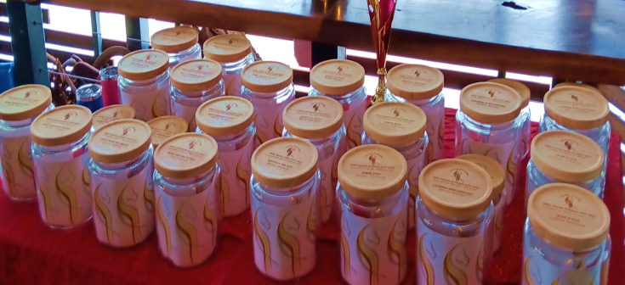
CARLY DOMROW

CHAMPION HALTER MARE
LUCKY N LOVE
CARLY DOMROW

CHAMPION HALTER GELDING
MIDAS TOUCHED IN GOLD
KERRI KILLIAN

CHAMPION UNDER SADDLE
MIDAS TOUCHED IN GOLD
KERRI KILLIAN

QLD HOTY BUCKSKIN 2022/2023

CHAMPION HALTER MARE
LAZY D GAMBLERS MELODY
OLIVIA PENNISI

RESERVE CHAMPION UNDER SADDLE
LAZY D GAMBLERS MELODY
OLIVIA PENNISI

RESERVE CHAMPION BEST PRESENTED
LAZY D GAMBLERS MELODY
OLIVIA PENNISI

CHAMPION UNDER SADDLE
LEAMBRO SOMELIKEITHOT
WENDY BROWN

CHAMPION HALTER GELDING
LEAMBRO SOMELIKEITHOT
WENDY BROWN

CHAMPION BEST PRESENTED
LEAMBRO SOMELIKEITHOT
WENDY BROWN

RESERVE CHAMPION HALTER GELDING
MOLLY’S SUMMERDEL
ELLIE STENZEL

QLD HOTY NSD 2022/2023

CHAMPION HALTER GELDING
JOHROY ICE MAGIC
BARB BRISKEY

CHAMPION UNDER SADDLE
JOHROY ICE MAGIC
BARB BRISKEY

QLD ANCILLARY HOTY 2022/2023

CHAMPION HALTER MARE
POWER HUGS
TONEAL HOFFMAN

CHAMPION BEST PRESENTED
POWER HUGS
TONEAL HOFFMAN

CHAMPION UNDER SADDLE
JOHROY ICE MAGIC
BARB BRISKEY

CHAMPION HALTER GELDING
JOHROY ICE MAGIC
BARB BRISKEY

RESERVE CHAMPION UNDER SADDLE
MIDAS TOUCHED IN GOLD
KERRI KILLIAN

QLD CREMELLO HOTY 2022/2023

CHAMPION BEST PRESENTED
MOUNTAIN CRK DIOR
WENDY BROWN

CHAMPION HALTER MARE
MOUNTAIN CRK DIOR
WENDY BROWN

CHAMPION HALTER GELDING
SIERRA LODGE ILLUMINATION
KRISTIE SULLIVAN

