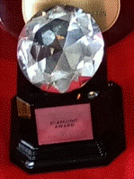
DIAMOND AWARDS 2022/2023

LAZY D GAMBLERS MELODY
Has already gained Bronze, Silver, Gold awards AND
has now gained her Diamond award

LUCKY N LOVE
Has gained Bronze, Silver & Gold awards

JOHROY ICE MAGIC
Has gained her Gold Award

MOUNTAIN CRK DIOR
Has gained Bronze, Silver, Gold awards

PRISM

JOHROY ICE MAGIC
Has gained her Gold Award

DAWNSTAR CHESNA
Has gained her Gold Award

POWER HUGS
Has gained Bronze, Silver, Gold
