DILUTES AUSTRALIA 2022/2023 HI POINTS

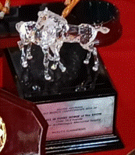
OVERALL HI POINT HORSE OF THE SHOW OVER 10.2 HANDS
Kilmaine Archimagus Memorial Trophy – Swarovski Crystal Horse
Donated by Peter & Gail Rossington
MOLLY’S SUMMERDEL
ELLIE STENZEL

HI POINT PERFORMANCE HORSE OF THE SHOW OVER 10.2 HANDS
The Lorraine Byrne Memorial Trophy Donated by Dilutes Australia Ltd.
MOLLY’S SUMMERDEL
ELLIE STENZEL
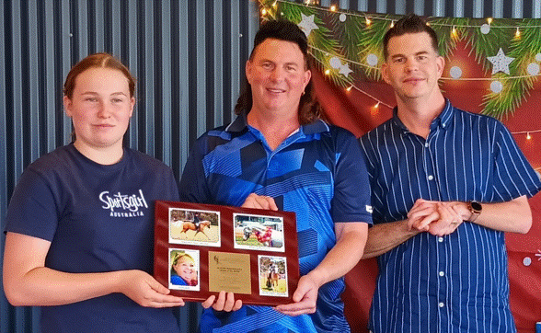

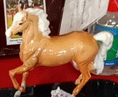
HI POINT PALOMINO OVER 10.2 HANDS
The “Palomino Jack” Memorial Trophy In Memory of Jack Bayard
JOHROY RISING SUN
KERRI JOHNSTONE

HI POINT BUCKSKIN/SMOKY BLACK/ DUN OVER 10.2 HANDS
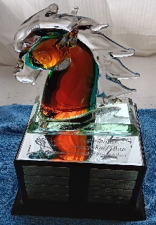
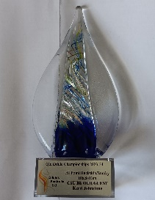
Perpetual Trophy & Replica Donated by The Dilutes Aust. Ltd. Qld Branch
CSU BE OUR GUEST
KERRI JOHNSTONE

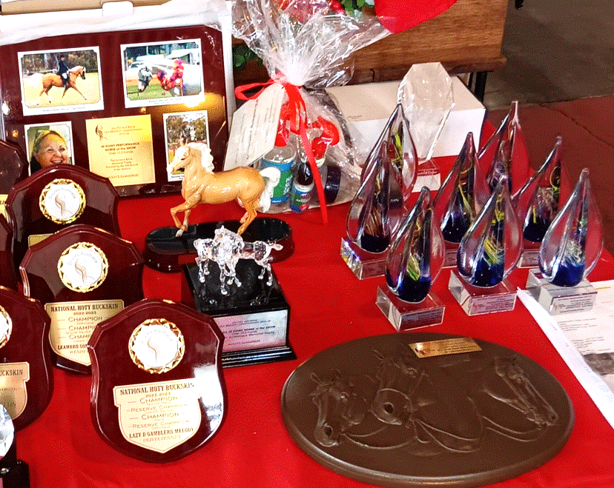
HI POINT AOSD OVER 10.2 HANDS
Sponsored by Rydan Welsh Ponies
MOUNTAIN CRK DIOR
WENDY BROWN

DA NON-SOLID DILUTE OVER 10.2 HANDS
CYNBEL LODGE KADADU JIM
DIANNA KIMBALL & FAMILY

HI POINT ANCILLARY DILUTE OVER 10.2 HANDS
BRAMPTON VOODOO CHARM
NARELLE POLLARD

HI POINT PERFORMANCE NON-DILUTE ANCILLARY/NCCD OVER 10.2 HANDS
ORARAPARK TOP SPIN
KAYLENE KEARNEY

HI POINT 2YEARS & UNDER VERSITILITY OVER 10.2 HANDS
POWER HUGS
TONEAL HOFFMAN

HI POINT WESTERN PERFORMANCE OVER 10.2 HANDS
JCJ GOLD RUSH DOWNUNDER
LATEISHA BRISKEY

HI POINT DRESSAGE
Sponsored & Supplied by Kelly Stenzell
FLENSBURG CORMINDI
OLIVIA TAYLOR

OVERALL HI POINT HORSE OF THE SHOW UNDER 10.2
SILHOUETTE ALMIGHTY RENDEZVOUS
KATY DRIVER
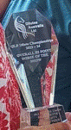

HI POINT BUCKSKIN/SMOKY BLACK/DUN
WILLOW VALLEY BRONTE BUCKSTAR
AIMEE KERWICK

HI POINT AOSD
SHIRALEE MIRAGE
KATY DRIVER

HI POINT NSD
MILO UNIQUE ELEGANCE
EDWARD WAGNER

HI POINT PERFORMANCE
SILHOUETTE ALMIGHTY RENDEZVOUS
KATY DRIVER

